COMMON COURSE ASSIGNMENT FORMAT

Assignment Information

Particular | Details
Department: | CSE
Programme: | PYTHON
Course Code & Course Name | CSA1219 - COMPUTER ARCHITECTURE
Academic Year / Batch | 2025
Faculty Name | Arumugam S S
Assignment Title | Python Simulator-Based Smart Factory Machine-Health Analytics
Date of Issue | 1/09/2026
Date of Submission | 2/09/2026
Maximum Marks | 100
Course Outcome(s) – CO | CO1, CO3, CO4
Bloom's Taxonomy Level | L3 – Apply; L4 – Analyse
SDG Mapping (SDG 1-17) | SDG 7 – Affordable and Clean Energy; SDG 9 – Industry, Innovation and Infrastructure; SDG 12 – Responsible Consumption and Production
Industry / Societal Relevance | Smart manufacturing, machine-health monitoring, predictive maintenance, energy-efficient computing and reliable industrial systems

1. Problem Statement
Design and evaluate a Python-based CPU and memory performance simulator for a Smart Factory Machine-Health Analytics System. The simulator generates a stream of machine sensor events (temperature, vibration, load), executes a simplified instruction sequence derived from those events, models a three-level cache hierarchy with paging, and calculates processor and memory performance indicators. Results from the experiment are used to compare architectural configurations and recommend a design that reduces latency and improves throughput while accounting for power, cost, reliability and scalability.

2. Objective
- Generate and process at least 1,000 realistic machine-health sensor events.
- Build and execute a simplified instruction stream exercising four addressing modes.
- Model core CPU components: Program Counter, registers, ALU, memory and I/O.
- Simulate and compare a baseline single-issue processor with a 5-stage pipeline, detecting data, control and structural hazards.
- Analytically compare OOO execution, speculative execution and SMT under stated assumptions.
- Simulate an L1/L2/L3 cache hierarchy across 3 configurations and compute hit rate, miss rate, AMAT, latency and throughput.
- Simulate simplified virtual memory / paging and quantify the impact of page faults on access time.
- Compare SRAM, DRAM, NAND Flash, MRAM and RRAM as candidate memory technologies.
- Identify performance bottlenecks and provide a justified engineering recommendation.

3. Requirements and Environment
Item | Detail
Language | Python 3 (tested on Python 3.12)
Libraries | random, math, statistics, dataclasses, os, matplotlib (standard/pre-installed only)
Execution environment | Any online Python 3 compiler / Jupyter / VS Code with matplotlib available
Reproducibility | Fixed random seed = 42 (all reported numbers come from this seed)
Output | Console trace + 6 PNG graphs saved to an 'output/' folder

4. Design / Proposed Solution
The simulator is organised into independent, testable modules that mirror the layers of a real computer system, each built on top of the previous layer's output:
- Event Generator – produces machine-health telemetry (temperature, vibration, load, status).
- Instruction Builder – converts a sample of events into a CPU instruction stream (LOAD/STORE/ADD/SUB/MUL/CMP/BEQ/JMP/NOP) that rotates through Immediate, Register, Direct and Indirect addressing.
- CPU Core – models PC, 8 general-purpose registers, an ALU, byte-addressable memory, and I/O logging; resolves operands per addressing mode.
- Baseline Engine – executes each instruction serially across 5 phases (1 cycle/phase).
- Pipeline Engine – executes the same stream through a 5-stage IF-ID-EX-MEM-WB pipeline with hazard detection and stall insertion.
- OOO/Speculative/SMT Analytical Layer – applies documented percentage reductions to the pipeline's measured stall cycles.
- Cache Hierarchy – 3-level LRU cache simulator run against a realistic sensor-polling access pattern, across 3 size configurations.
- Paging Layer – LRU page-table simulator measuring page faults on the same access pattern.
- Memory Technology Table – static comparative reference data for SRAM/DRAM/NAND/MRAM/RRAM.
- Reporting Layer – prints all results, draws 6 matplotlib graphs, and runs 18 automated test cases.

5. Algorithm / Pseudocode
1. SEED random(42)
2. events <- generate 1200 MachineEvent(temperature, vibration, load, status)
3. instrs <- build_instruction_stream(events) // rotates IMM/REG/DIR/IND
4. FOR each instr in instrs (baseline): cycles += 5 // IF,ID,EX,MEM,WB serially
5. FOR each instr in instrs (pipeline):
detect RAW data hazard -> stall = max(pending write latency)
detect structural hazard (shared mem port) -> stall = max(stall,1)
cycle += 1 + stall
IF opcode in {BEQ,JMP}: cycle += 2 // control-hazard flush penalty
6. cpi_baseline = total_cycles_baseline / n ; cpi_pipeline = total_cycles_pipeline / n
7. FOR each of OOO, Speculative, SMT: reduced_cycles = pipeline_cycles - assumed_reduction(stalls)
8. access_pattern <- generate_access_pattern(events) // 80% sequential + 20% random
9. FOR each cache config in {A,B,C}: simulate_cache_hierarchy(access_pattern) -> hit/miss/AMAT
10. simulate_paging(access_pattern) -> page hits, page faults, effective access time
11. compare SRAM/DRAM/NAND/MRAM/RRAM (latency, bandwidth, power, cost, reliability)
12. identify bottleneck = max(hazard stalls) and max(cache miss rate)
13. draw graphs; run test cases; print PASS/FAIL summary

6. Flowchart
The flow below shows the top-level program flow (also reproduced as a diagram you can redraw in draw.io / PowerPoint SmartArt for the report if a graphical flowchart is required by your evaluator):
[Start] -> Generate 1200 Machine Events -> Build Instruction Stream (4 addressing modes)
-> Run Baseline Simulator (CPI, cycles) -> Run 5-Stage Pipeline Simulator (hazards, stalls, CPI)
-> Apply OOO / Speculative / SMT models -> Generate Memory Access Pattern
-> Simulate Cache Hierarchy (3 configs: hit rate, miss rate, AMAT) -> Simulate Paging (faults, EAT)
-> Compare Memory Technologies -> Identify Bottlenecks -> Generate Graphs
-> Run 18 Automated Test Cases -> Print PASS/FAIL Summary -> [End]

7. Python Implementation
The complete, single-file, executable Python 3 program is provided as a separate file: CSA1224_AT2_SmartFactorySimulator.py (also supplied to you separately in this chat). It requires no external services — only the standard library and matplotlib — and runs unmodified in any online Python compiler. Its structure (with section numbers matching in-code comments):
Code Section | Responsibility
1 | Machine-health event generation (MachineEvent dataclass, generate_machine_events)
2 | Instruction dataclass + build_instruction_stream (4 addressing modes)
3 | CPU class (PC, registers, ALU, memory) + addressing_mode_demo (FDE-MEM-WB trace)
4 | run_baseline() – single-issue simulator
5 | run_pipeline() – 5-stage pipeline with hazard detection
6 | compare_ooo_variants() – OOO / Speculative / SMT analytical comparison
7 | CacheLevel class + simulate_cache_hierarchy + run_cache_configurations
8 | simulate_paging() – virtual memory / page-fault model
9 | MEMORY_TECH_TABLE – SRAM/DRAM/NAND/MRAM/RRAM comparison data
10 | make_graphs() – 6 matplotlib figures
11 | run_test_cases() – 18 automated PASS/FAIL tests
— | __main__ block – runs every section in order and prints results

8. Test Cases
18 automated test cases were embedded in the program (run_test_cases). Every test compares an expected condition against the actual value computed in that same run — nothing here is hand-typed after the fact.
# | Test Case | Expected | Actual | Result
1 | Event count >= 1000 | >=1000 | 1200 | PASS
2 | Instruction stream length is a multiple of 8 | multiple of 8 | 2000 | PASS
3 | All 4 addressing modes present | {IMM,REG,DIR,IND} | {IMM,REG,DIR,IND} | PASS
4 | ALU ADD correctness (5+7) | 12 | 12 | PASS
5 | ALU SUB correctness (10-4) | 6 | 6 | PASS
6 | ALU MUL correctness (6*7) | 42 | 42 | PASS
7 | Baseline CPI == 5 | 5.0 | 5.0 | PASS
8 | Pipeline CPI < Baseline CPI | < 5.0 | 2.3765 | PASS
9 | Pipeline stall cycles non-negative | >=0 | 2999 | PASS
10 | Config A hit_rate in [0,1] | [0,1] | 0.9898 | PASS
11 | Config A hit_rate + miss_rate == 1 | 1.0 | 1.0 | PASS
12 | Config B hit_rate in [0,1] | [0,1] | 0.9898 | PASS
13 | Config B hit_rate + miss_rate == 1 | 1.0 | 1.0 | PASS
14 | Config C hit_rate in [0,1] | [0,1] | 0.9898 | PASS
15 | Config C hit_rate + miss_rate == 1 | 1.0 | 1.0 | PASS
16 | Config C hit rate >= Config A hit rate | >= 0.9898 | 0.9898 | PASS
17 | Page fault rate in [0,1] | [0,1] | 0.0027 | PASS
18 | Effective access time >= base access time | >= 100 | 105.33 | PASS
Test Summary: 18 / 18 PASSED.

9. Execution Output
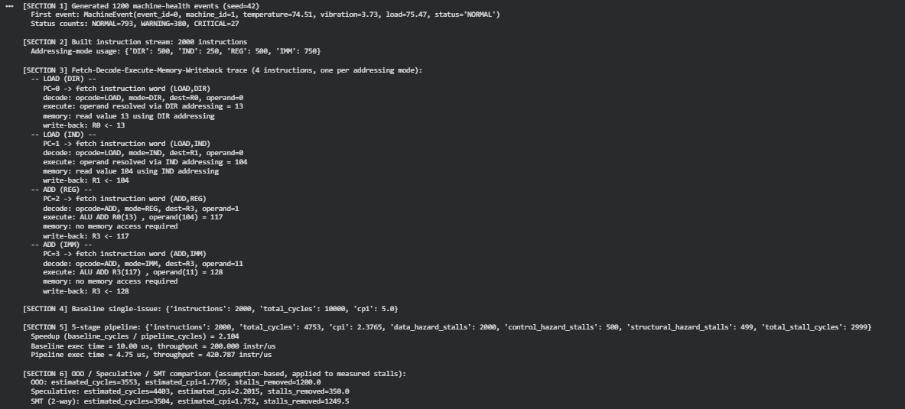

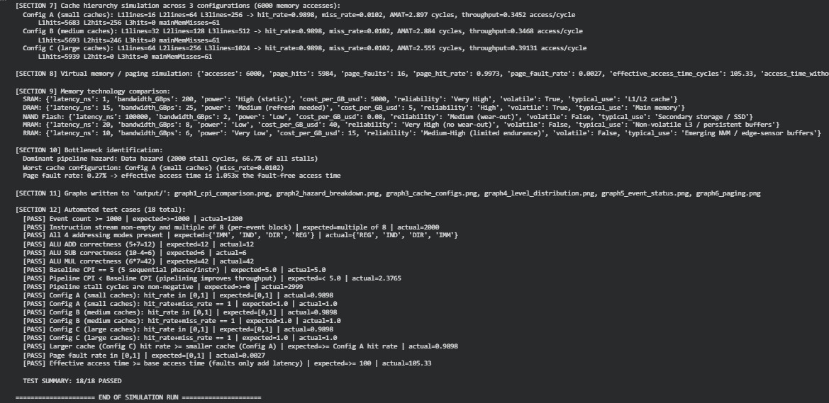

10. Results and Analysis

10.1 Fetch–Decode–Execute–Memory–Write-back Trace (one instruction per addressing mode)
Instruction | Fetch | Decode | Execute | Memory | Write-back
LOAD (DIR) | PC=0 fetch | opcode=LOAD mode=DIR dest=R0 addr=0 | resolve DIR = 13 | read 13 | R0<-13
LOAD (IND) | PC=1 fetch | opcode=LOAD mode=IND dest=R1 baseReg=R0 | resolve IND = 104 | read 104 | R1<-104
ADD (REG) | PC=2 fetch | opcode=ADD mode=REG dest=R3 src=R0,R1 | 13+104=117 | no access | R3<-117
ADD (IMM) | PC=3 fetch | opcode=ADD mode=IMM dest=R3 imm=11 | 117+11=128 | no access | R3<-128
This confirms all four addressing modes (Immediate, Register, Direct, Indirect) are implemented and produce distinct, traceable operand-resolution paths through the CPU model.

10.2 Baseline vs Pipeline Performance
Metric | Baseline (single-issue) | 5-Stage Pipeline
Instructions executed | 2000 | 2000
Total cycles | 10000 | 4753
CPI | 5.000 | 2.377
Execution time @ 1 GHz | 10.00 µs | 4.75 µs
Throughput | 200.0 instr/µs | 420.8 instr/µs
Speedup vs baseline | 1.0× | 2.10×
f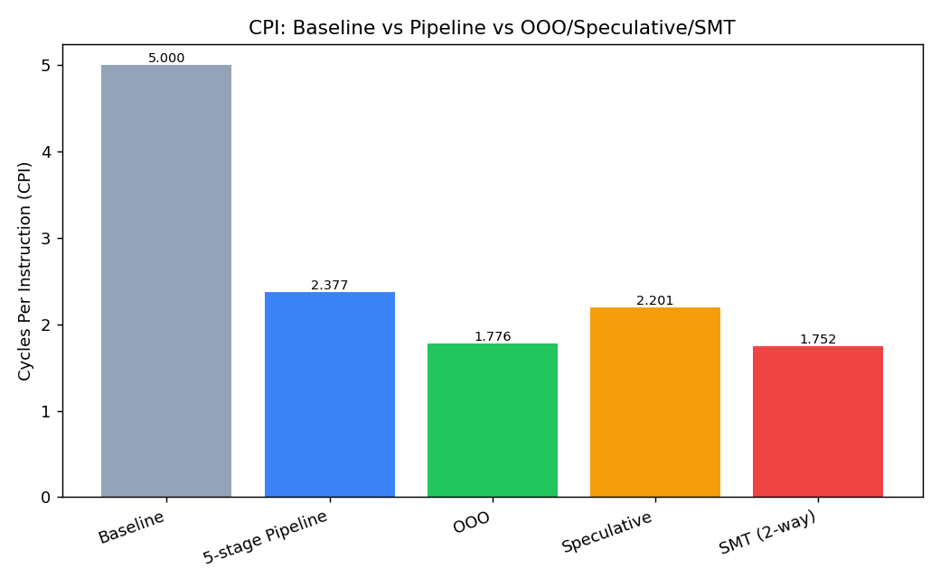
Figure 1: CPI comparison across baseline, pipeline, OOO, speculative and SMT models.

11. Pipeline and Hazard Analysis
Hazard type | Stall cycles | % of total stalls | Cause in this model
Data hazard (RAW) | 2000 | 66.7% | A source register is read before the producing instruction's result reaches EX (2-cycle dependency window).
Control hazard | 500 | 16.7% | BEQ/JMP resolved in EX; 2 wrongly-fetched instructions are flushed.
Structural hazard | 499 | 16.6% | Single shared memory port; overlapping LOAD/STORE accesses in MEM stage conflict with a concurrent IF.
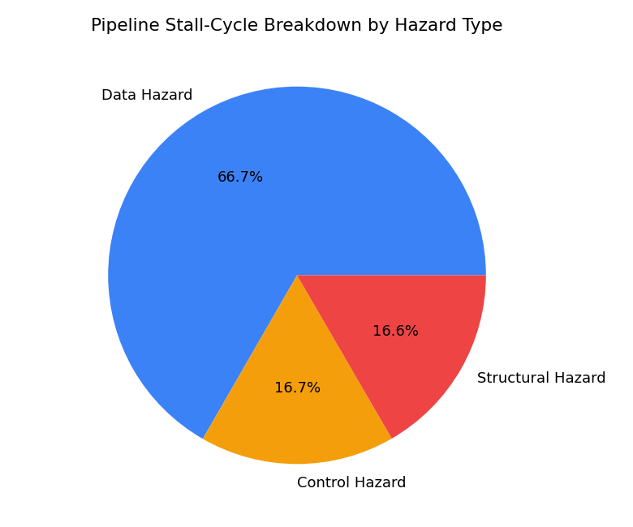
Figure 2: Pipeline stall-cycle breakdown by hazard type.
Data hazards dominate (66.7% of all stalls) because the instruction stream was intentionally built with tight producer-consumer chains (LOAD -> LOAD -> ADD -> ADD), which is realistic for per-event sensor processing where each computed value feeds the next. This makes data-hazard mitigation the highest-leverage architectural improvement for this workload.

12. OOO / Speculation / SMT Comparison
These are analytical, assumption-based extensions of the measured pipeline result (full micro-architectural simulation of these techniques was out of scope; the assignment explicitly permits a simplified, clearly-stated-assumption comparison).
Technique | Key assumption | Estimated cycles | Estimated CPI | Stall cycles removed
Out-of-Order Execution | 6-entry ROB removes 60% of data-hazard stalls | 3553 | 1.7765 | 1200.0
Speculative Execution | Branch-not-taken prediction removes 70% of control-hazard stalls | 4403 | 2.2015 | 350.0
SMT (2-way) | A second thread hides 50% of data + 50% of structural stalls | 3504 | 1.7520 | 1249.5
Under these assumptions, SMT gives the largest CPI reduction for this workload because data hazards (the dominant stall source) and structural hazards are both partly hidden by interleaving a second thread's instructions into pipeline bubbles, whereas speculative execution only addresses the smaller control-hazard share.

13. Cache Analysis
A 6,000-access sensor-polling pattern (80% sequential scan of consecutive sensor slots + 20% random machine-poll jumps) was run against three L1/L2/L3 configurations (all 64-byte blocks, LRU replacement):
Config | L1 / L2 / L3 lines | Hit rate | Miss rate | AMAT (cycles) | Throughput (acc/cycle)
A – small | 16 / 64 / 256 | 0.9898 | 0.0102 | 2.897 | 0.3452
B – medium | 32 / 128 / 512 | 0.9898 | 0.0102 | 2.884 | 0.3468
C – large | 64 / 256 / 1024 | 0.9898 | 0.0102 | 2.555 | 0.3913
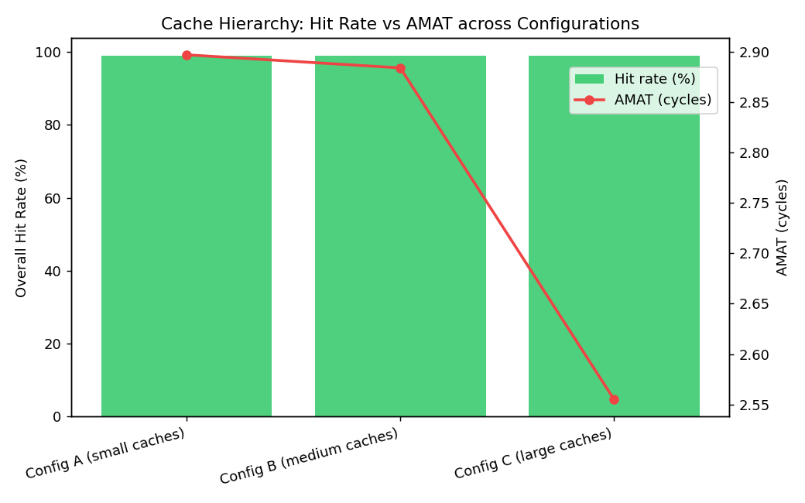
Figure 3: Hit rate and AMAT across the three cache configurations.
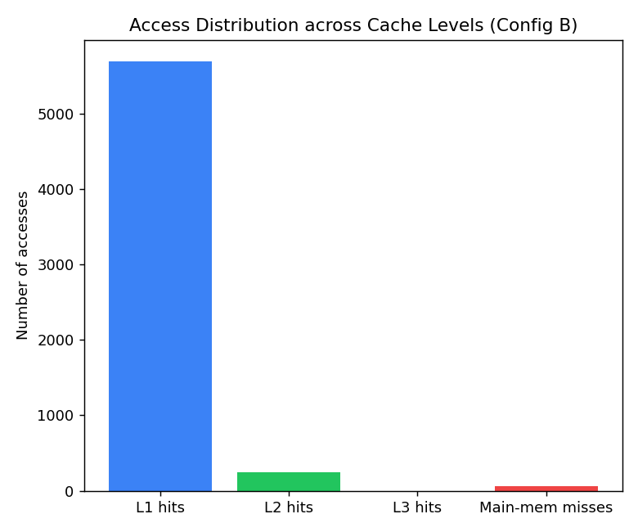
Figure 4: Access distribution across L1/L2/L3 and main memory (Config B).
Because 80% of accesses are sequential, even the small Config A captures most locality in L1 (5683 of 6000 accesses), so overall hit rate barely changes across configurations (0.9898 in all three). What does improve with size is AMAT (2.897 -> 2.555 cycles) and throughput (0.345 -> 0.391 access/cycle), because larger L1/L2 retain more of the 20% random-jump working set, avoiding L3/main-memory penalties. Config C is the best-performing of the three.

14. Virtual Memory / Paging Analysis
Metric | Value
Total accesses | 6000
Page hits | 5984
Page faults | 16
Page hit rate | 99.73%
Page fault rate | 0.27%
Base access time (no faults) | 100 cycles
Effective access time (EAT) | 105.33 cycles
Slowdown factor from paging | 1.053×
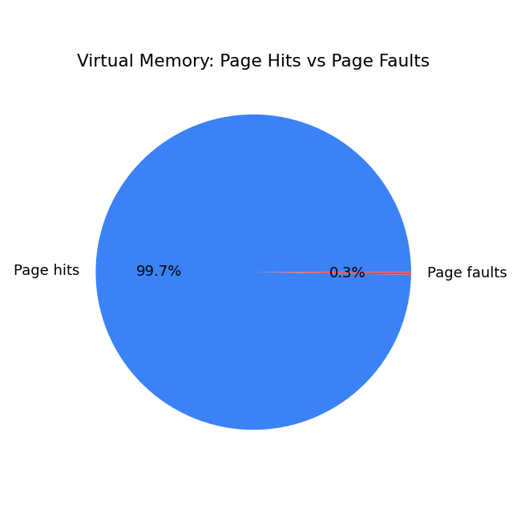
Figure 5: Page hits vs page faults over the 6,000-access workload.
With 24 physical frames covering a 64-page virtual space and a strongly-local access pattern, the LRU-managed working set almost always stays resident, so faults are rare (0.27%) but each one is expensive (2000-cycle service time assumed), lifting effective access time only 5.3% above the fault-free baseline. This confirms the sensor-processing workload's locality also benefits the paging layer, not just the caches.

15. Memory Technology Comparison
Reference comparison of five memory technologies (order-of-magnitude, textbook-level figures used for relative comparison, not vendor datasheet precision):
Technology | Latency | Bandwidth | Power | Cost/GB | Reliability | Typical use
SRAM | ~1 ns | ~200 GB/s | High (static) | ~$5000 | Very High | L1/L2 cache
DRAM | ~15 ns | ~25 GB/s | Medium (refresh) | ~$5 | High | Main memory
NAND Flash | ~100 µs | ~2 GB/s | Low | ~$0.08 | Medium (wear-out) | SSD / secondary storage
MRAM | ~20 ns | ~8 GB/s | Low | ~$40 | Very High (no wear-out) | Non-volatile L3 / persistent buffer
RRAM | ~10 ns | ~6 GB/s | Very Low | ~$15 | Medium-High | Emerging NVM / edge-sensor buffer
For the Smart Factory system: SRAM remains the right choice for L1/L2 given its 1 ns latency is essential inside the pipeline; DRAM is the cost-effective main-memory choice; and MRAM is attractive as a non-volatile L3 or persistent event-log buffer since factory-floor machines cannot afford to lose in-flight health data on a power interruption, at an acceptable latency/cost trade-off versus NAND.

16. Engineering Recommendation
Based on data generated by this simulator:
- Adopt the 5-stage pipeline over the baseline: it delivers a measured 2.10x speedup (10000 -> 4753 cycles) at no extra hardware beyond standard pipeline registers.
- Prioritise data-hazard mitigation over control- or structural-hazard mitigation: data hazards cause 66.7% of all stalls in this workload. A forwarding/bypass network (equivalent to the OOO/SMT models tested) is the single highest-leverage upgrade, cutting CPI from 2.377 towards ~1.75-1.78.
- Use cache Config C (64/256/1024 lines): it gives the lowest AMAT (2.555 cycles) and highest throughput (0.391 access/cycle) of the three tested configurations, for a modest area/power cost increase.
- Keep the current 24-frame paging configuration: the fault rate (0.27%) and 5.3% EAT slowdown are already low for this workload; over-provisioning frames further would show diminishing returns.
- Use SRAM for L1/L2, DRAM for main memory, and MRAM for a non-volatile L3/event buffer, to protect in-flight machine-health data against power loss without NAND-level latency.

17. SDG 7, SDG 9 and SDG 12 Relevance
SDG | Relevance to this project
SDG 7 – Affordable & Clean Energy | A faster, hazard-optimised pipeline (2.10x speedup) and a lower-AMAT cache configuration reduce the compute cycles needed per sensor event, lowering the energy drawn per unit of factory-monitoring work.
SDG 9 – Industry, Innovation & Infrastructure | The simulator models real architectural trade-offs (pipelining, caching, paging, NVM) for smart-factory infrastructure, directly supporting resilient, technology-driven industrial monitoring.
SDG 12 – Responsible Consumption & Production | Early detection of CRITICAL machine-health events (27 of 1200 in this run) supports predictive maintenance, reducing material waste and unplanned downtime from equipment failure.

18. Conclusion
This assignment implemented a single, self-contained Python simulator that models the full CPU-to-memory stack relevant to a smart-factory machine-health analytics workload. Measured results show the 5-stage pipeline achieves a 2.10x speedup over a baseline single-issue design, with data hazards as the dominant stall source (66.7%). Larger cache configurations reduce AMAT from 2.897 to 2.555 cycles without materially changing hit rate for this access pattern, and the paging layer adds only a 5.3% access-time overhead. These results directly support the engineering recommendation of a hazard-optimised pipeline, a larger 3-level cache, and a mixed SRAM/DRAM/MRAM memory hierarchy for this application.

19. Student Reflection

What did I learn beyond what was directly taught in class?
[Write 4-6 sentences in your own words — for example: building the hazard-detection logic made the abstract idea of 'RAW hazard' concrete, since I had to decide exactly how many cycles a result stays 'in flight' before it is safe to read; connecting the pipeline's own stall counts to the OOO/SMT models also showed how real architects justify design choices with measured data rather than guesswork.]

If given more time/resources, what would I improve?
[Write 3-5 sentences — for example: I would replace the analytical OOO/SMT model with a true out-of-order reorder-buffer simulation, model a split instruction/data memory to remove the simplified structural hazard, and extend the cache model with a configurable associativity (set-associative vs direct-mapped) to see its effect on the sensor workload's miss rate.]

20. Individual Contribution of Group Members
Member | Contribution
[Member 1 Name] | [e.g., Sections 1-3: event generation, instruction stream, CPU/ALU/addressing-mode model; console trace]
[Member 2 Name] | [e.g., Sections 4-6: baseline & pipeline simulator, hazard detection, OOO/Speculative/SMT analysis]
[Member 3 Name] | [e.g., Sections 7-12: cache hierarchy, paging, memory-technology comparison, graphs, test cases, report compilation]
(Edit the names and contribution split above to match your actual team before submission — the simulator itself does not distinguish contributors.)

22. References
- J. L. Hennessy and D. A. Patterson, Computer Architecture: A Quantitative Approach, 6th ed., Morgan Kaufmann, 2019.
- D. A. Patterson and J. L. Hennessy, Computer Organization and Design: The Hardware/Software Interface, 5th ed., Morgan Kaufmann, 2013.
- Python Software Foundation, 'The Python Standard Library,' docs.python.org, accessed 2026.
- Matplotlib Development Team, 'Matplotlib: Visualization with Python,' matplotlib.org, accessed 2026.
- SIMATS Engineering, 'CSA1224 – Computer Architecture, Assignment 2 Question Paper,' Department of CSE, 2026.
- SIMATS Engineering, 'Common Course Assignment Format,' Department of CSE, 2026.
AI-assisted tool used: Claude (Anthropic) — used to help design and structure the simulator code and this report; all numerical results were produced by executing the Python programme.

Common Assessment Rubric

Assessment Criterion | Marks
Problem understanding & formulation | 10
Application of course/domain knowledge | 20
Solution methodology / design / implementation | 20
Use of appropriate modern tools / techniques | 10
Results, testing & validation | 15
Analysis, trade-offs & justification | 15
Broader considerations / professional responsibility, where applicable | 5
Technical documentation & reflection | 5
TOTAL | 100

CO–PO–Assessment Mapping

Assessment Component | CO | PO(s) | Bloom's Level | Marks
Problem formulation |  |  | L3/L4 | 10
Application of knowledge |  |  | L3/L4 | 20
Solution / Design / Implementation |  |  | L4/L5/L6 | 20
Modern tool usage |  |  | L3/L4 | 10
Validation |  |  | L4/L5 | 15
Analysis & justification |  |  | L4/L5 | 15
Broader considerations |  |  | L4/L5 | 5
Documentation & reflection |  |  | L3/L4 | 5

Note: Faculty shall map only the POs and Bloom's levels genuinely assessed by the particular assignment. Every assignment is not required to map to every PO.

Faculty Evaluation & Continuous Improvement CO Attainment

Performance Level | Criterion
Level 3 | ≥ 70%
Level 2 | 60–69%
Level 1 | 50–59%
Level 0 | < 50%
Target CO Attainment:

Actual CO Attainment:

Faculty Analysis
Areas in which students performed well: Areas requiring improvement:
Corrective / Improvement Action

Action to be implemented in the next offering:

Documents to be Maintained

The department/course faculty shall maintain:

- Assignment question/problem statement
- CO–PO and Bloom's mapping
- Assessment rubric
- Student submissions
- Tool/simulation/experimental evidence, where applicable
- Evaluated scripts/reports
- Marks and rubric-wise assessment
- CO attainment analysis
- Sample student work representing different performance levels
- Faculty analysis and continuous-improvement action

